|  |  |  |  |  |  |  |  |  |  |  |  |  |
| --- | --- | --- | --- | --- | --- | --- | --- | --- | --- | --- | --- | --- |
| |  |  | | --- | --- | | **Semester One Examination 2018** | ccc-logo | | **Question/Answer Booklet** |   **PHYSICS**  **12 ATAR**   |  |  |  | | --- | --- | --- | | Student  Number: | In  Figures |  | |  | In words |  | |  |  |  | |

**Time allowed for this paper**

Reading time before commencing work: Ten minutes

Working time for paper: Three hours

**Materials required/recommended for this paper**

***To be provided by the supervisor***

This Question/Answer Booklet/Formulae and Data Booklet

***To be provided by the candidate***

Standard items: pens (blue/black preferred), pencils (including coloured), sharpener, correction tape/fluid, eraser, ruler and highlighters

Special items: non-programmable calculators approved for use in this examination, drawing templates, drawing compass and a protractor

**Important note to candidates**

No other items may be taken into the examination room. It is **your** responsibility to ensure that you do not have any unauthorised material. If you have any unauthorised material with you, hand it to the supervisor **before** reading any further.

**Structure of this paper**

|  |  |  |  |  |  |
| --- | --- | --- | --- | --- | --- |
| Section | Number of questions available | Number of questions to be answered | Suggested working time (minutes) | Marks available | Percentage of exam |
| Section One: Short answers | 11 | 11 | 50 | 54 | 30 |
| Section Two: Problem-solving | 6 | 6 | 90 | 90 | 50 |
| Section Three: Comprehension | 2 | 2 | 40 | 36 | 20 |
|  |  |  |  | Total | 100 |

**Instructions to candidates**

1. The rules for the conduct of the Western Australian Certificate of Education ATAR course examinations are detailed in the *Year 12 Information Handbook 2017*. Sitting this examination implies that you agree to abide by these rules.
2. Write your answers in this Question/Answer booklet.
3. When calculating or estimating answers, show all your working clearly. Your working should be in sufficient detail to allow your answers to be checked readily and for marks to be awarded for reasoning.

In calculations, give final answers to three significant figures and include appropriate units where applicable.

In estimates, give final answers to a maximum of two significant figures and include appropriate units where applicable.

1. You must be careful to con ne your answers to the specific questions asked and to follow any instructions that are specific to a particular question.
2. Additional working space pages at the end of this Question/Answer booklet are for planning or continuing an answer. If you use these pages, indicate at the original answer, the page number it is planned/continued on and write the question number being planned/continued on the additional working space page.
3. The Formulae and Data booklet is not to be handed in with your Question/Answer booklet.

**­­­­­­­­­**

**Section One. Short response. 30% (54 Marks)**

This section has **11** questions. Answer **all** questions. Write your answers in the spaces provided.

When calculating numerical answers, show your working or reasoning clearly. Give final answers to **three** significant figures and include appropriate units where applicable.

When estimating numerical answers, show your working or reasoning clearly. Give final answers to a maximum of **two** significant figures and include appropriate units where applicable.

Additional working space pages at the end of this Question/Answer booklet are for planning or continuing an answer. If you use these pages, indicate at the original answer, the page number it is planned/continued on and write the question number being planned/continued on the additional working space page.

Suggested working time: 50 minutes.

**­­­­­­­­­**

**­­­­­­­­­**

**Question 1 (3 marks)**

The diagram below shows the trajectory of a projectile as it travels from left to right

(i.e. from X to Y to Z).

Y

Z

X

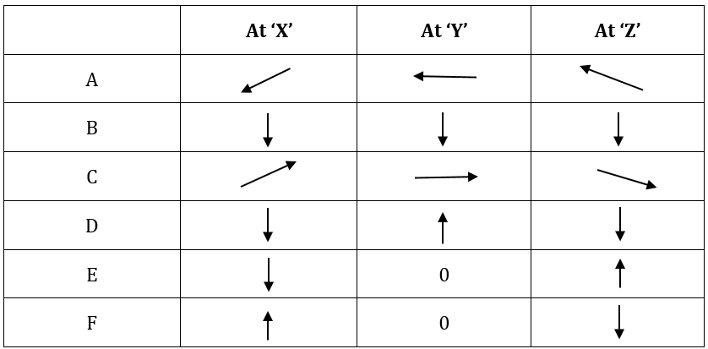

(a) Which set of vectors (A – F) best illustrates the acceleration experienced by the ball in flight (ignore air resistance)? (1 mark)

(b) Which set of vectors (A – F) best illustrates the instantaneous velocity of the ball in flight (ignore air resistance)? (1 mark)

(c) If air resistance is taken into account, which set of vectors best illustrates the force due to this air resistance experienced by the ball in flight? (1 mark)

WACE 2016 Q 3

**Question 2 (5 marks)**

The banking of roads can help cars navigate high speed bends safely. Derive an equation to calculate the angle to the horizontal that a road should be inclined for a 1.50 x 103 kg car to negotiate a horizontal circular path with a radius of 2.50 x 102 m at 1.10 x 102 kmh-1.

(Ignore the frictional effects of the road on the car.)

Ian Wilson

<http://www.schoolphysics.co.uk/age16-19/Mechanics/Circular%20motion/text/Circular_Motion2/index.html>

**Question 3 (5 marks)**

The table below shows some data for two planets orbiting a distant star in another galaxy. Kepler's Third Law relates the radius and period of orbit for planets orbiting a star.

|  |  |  |  |  |  |
| --- | --- | --- | --- | --- | --- |
| **Planets** | **Mass (kg)** | **Orbital radius (m)** | **Radius of planet (m)** | **Length of one day (s)** | **Orbital period (s)** |
| Alpha | 1.15 x 1025 | 4.50 x 1011 | 7.90 x 106 | 9.60 x 104 | 8.50 x 107 |
| Beta | 1.60 x 1024 | 9.00 x 1011 | 3.80 x 106 | 4.80 x 104 | - |

Use this information and appropriate data from the table to calculate the value for the orbital period of Beta.

**Question 4 (5 marks)**

Ox PHYA2 Jun 15 Q 2b

A uniform, 35.0 kg horizontal platform is supported by two vertical steel cables ‘X’ and ‘Y’ situated 10.0 m apart as shown. A person with a mass of 85.0 kg stands 3.00 m from ‘X’.

**X**

**Y**

With the person in the position stated, calculate the tension in cables ‘X’ and ‘Y’.

**Question 5 (4 marks)**

The diagram shows a cyclist rounding a circular bend on his bicycle.

(a) Show with an arrow the net force on him as he rounds the bend. (1 mark)

(b) Explain why the rider must lean his bicycle as he takes

the corner. (3 marks)

_____________________________________________________________________

_____________________________________________________________________

_____________________________________________________________________

_____________________________________________________________________

_____________________________________________________________________

_____________________________________________________________________

_____________________________________________________________________

_____________________________________________________________________

Schaum College Physics pg 74 Q5.18

**Question 6 (5 marks)**

(a) On the following diagram, draw the magnetic fields between the magnets and the steel ball. (3 marks)

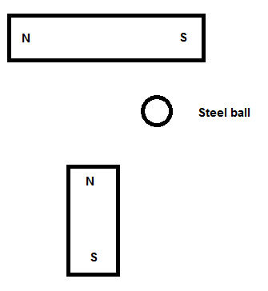

(b) Draw the electric field between the negative plate and the charged sphere in the following diagram. (2 marks)

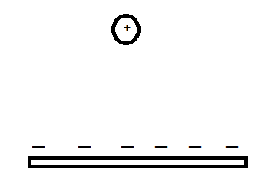

Ian Wilson

**Question 7 (4 marks)**

The diagram below shows a crane supporting a “heavy object” as shown. The “moving support” can be moved towards the “vertical support” or away from it.

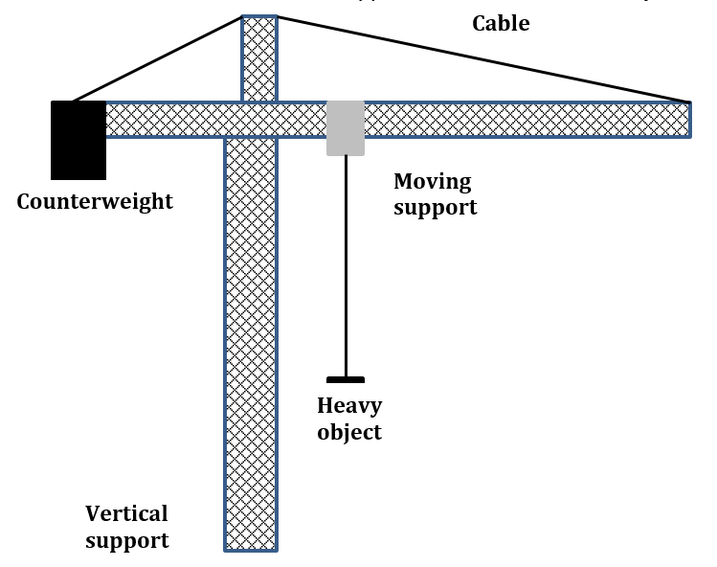

(a) Explain the role of the “counterweight” and “cable” in this structure. (2 marks)

_____________________________________________________________________

_____________________________________________________________________

_____________________________________________________________________

_____________________________________________________________________

_____________________________________________________________________

(b) Explain how the tension in the cable changes if the ‘heavy object” is moved to the right by the “moving support”. (2 marks)

_____________________________________________________________________

_____________________________________________________________________

_____________________________________________________________________

_____________________________________________________________________

_____________________________________________________________________

**Question 8 (7 marks)**

(a) On the diagram, show the magnetic field of the Earth. (3 marks)

N



S

(b) An alternating current of 125 A flows a 50.0 m span of transmission cable that is orientated in a north-south direction. The transmission cable is located at a point in Western Australia where the Earth's magnetic field intensity is 5.40 x 10-5 T at 60.0 ° angle of dip. Assume the cable is horizontal along its length.

At the instant that the current is flowing towards South, what would be the force acting on the length of the wire? (4 marks)

Bearth = 5.40 x 10-5 T

North

I = 125 A South

60.0°

**Looking west**

South

Ian Wilson

**Question 9 (5 marks)**

Schaum pg 200 Q 11.7 EM

An aeroplane is being flown with its maximum horizontal speed of 4.00 x 102 kmh-1 at an altitude of 1.50 x 103 m. A piece of the plane becomes dislodged and drops off it whilst it is in motion. If air resistance can be ignored, calculate the velocity of this piece of the plane when it lands on the ground (in ms-1).

**Question 10 (6 marks)**

The diagram below shows four positions on a rollercoaster track.

**D**

**A**

**B**

**C**

(a) At which point on the track do the occupants of a rollercoaster on the track experience MAXIMUM normal force? Justify your answer. (3 marks)

_____________________________________________________________________

_____________________________________________________________________

_____________________________________________________________________

_____________________________________________________________________

_____________________________________________________________________

_____________________________________________________________________

(b) The occupants of the rollercoaster feel ‘weightless’ at A. Derive an expression relating the instantaneous speed *v* of the rollercoaster and the radius of the track *r* at A to cause this sensation. (3 marks)

**Question 11 (5 marks)**

In an electrostatic spray painting system, droplets of paint are ejected from a positively charged spray gun to the object to be painted, which is negatively charged.

Droplets

Object to be painted

Spray gun

The magnitude of the charge on each droplet is 2.00 x 10-10 C and, on average, they have a diameter of about 1.50 x 102 μm.

(a) State whether electrons were added to or removed from the droplets of paint by the spray gun. (1 mark)

________________________________________________________________________

(b) Calculate the electrostatic force acting between adjacent droplets if their surfaces are virtually touching. (Assume the distance apart is the average diameter of a drop.)

(4 marks)

<http://mathcaddy.weebly.com/uploads/2/1/4/4/21446970/electromag_ws2.pdf> Q2

**­­­­­­­­­**

**Section Two. Problem-solving. 50% (90 Marks)**

This section has **6** questions. Answer **all** questions. Write your answers in the spaces provided.

When calculating numerical answers, show your working or reasoning clearly. Give final answers to **three** significant figures and include appropriate units where applicable.

When estimating numerical answers, show your working or reasoning clearly. Give final answers to a maximum of **two** significant figures and include appropriate units where applicable.

Additional working space pages at the end of this Question/Answer booklet are for planning or continuing an answer. If you use these pages, indicate at the original answer, the page number it is planned/continued on and write the question number being planned/continued on the additional working space page.

Suggested working time: 90 minutes.

**­­­­­­­­­**

**Question 12 (15 marks)**

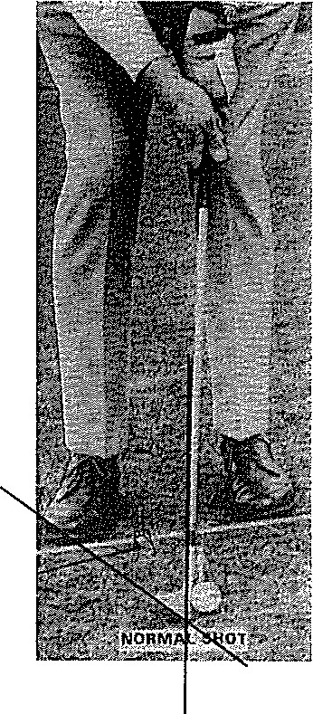

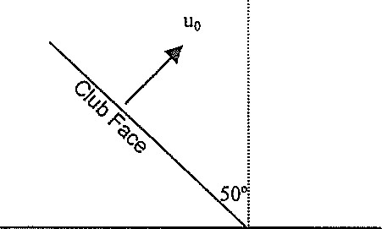

Green

D

A wedge is a golf club designed to hit the ball over short distances. When correctly hit, the ball does not roll when it arrives at its destination, the green. The green, or putting green, is the culmination of a golf hole, where the [flagstick](https://www.thoughtco.com/flagstick-role-in-golf-1560846) and [hole](https://www.thoughtco.com/different-meanings-of-hole-in-golf-1560880) are located. Getting the golf ball into the hole on the putting green is the object of the game of golf.

To do this, the club face is lofted. This means that the club face is inclined at 500 to the vertical as shown in the diagram above **(not drawn to scale).**

Assume that when hit, the ball leaves the club face **at right angles** to the face. The **horizontal distance of ball from launch point to putting green** is shown as **D**.

1. Write expressions giving the horizontal and vertical components of the ball's initial

velocity u0. (2 marks)

1. In terms of u0, t or D calculate each of the following, using appropriate equations:
2. the horizontal distance travelled by the ball after a time t. (2 marks)
3. the height of the ball at any time t. (2 marks)
4. **the horizontal distance from the ball to the green** at any time t. (2 marks)

Tiger Smith, a champion golfer, 100 m from the hole, aims and hits his ball. It lands nicely on the hole which is in the centre of the green. His wedge has a loft of 500 with the vertical.

With equations derived in (b) or otherwise, find

c) (i) the velocity with which the ball must leave the club and (2 marks)

(ii) the time the ball is in the air. (2 marks)

d) There is a large tree, 21 m tall, between Tiger and the green. If the tree is 70 m

from Tiger, determine with calculations if the ball will clear the tree. (3 marks)

**Question 13 (15 marks)**

The Kepler NASA mission aims to search for planets orbiting stars in other solar systems. The star named Kepler 20 has been observed to have several planets orbiting it. Kepler 20 is 950 light-years from Earth.

Information about Kepler 20 and some of the planets orbiting it is summarised in the table below.

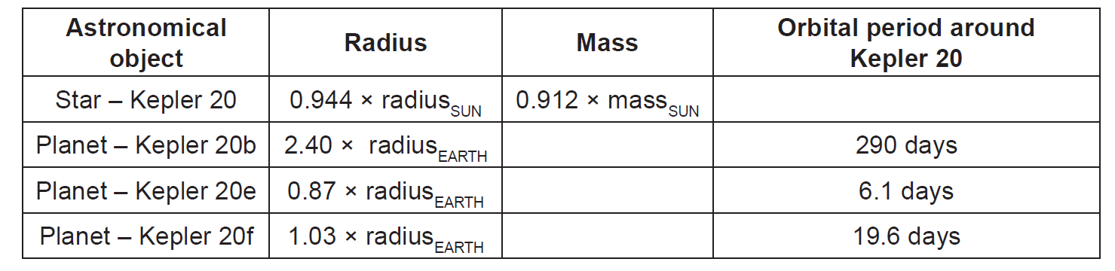

(a) A light-year is an astronomical unit of distance. It is defined as the distance

travelled by light in one year. Calculate the distance from Kepler 20 to Earth in

kilometres. (2 marks)

(b) Astronomers express the mass of Kepler 20 as (0.912 ± 0.035) × massSUN.

Calculate the maximum value astronomers expect for the mass of Kepler 20.

(2 marks)

(c) Calculate the orbital radius of Kepler 20e around Kepler 20. You should use

the mass for Kepler 20 quoted in the table and assume the orbit is circular.

(4 marks)

(d) The mass of Kepler 20b is unknown but it has been speculated that it may

have a density similar to that of Earth, 5520 kg m-3. Calculate the surface

gravity of Kepler 20b if its density is 5520 kg m-3. (4 marks)

Reminder:

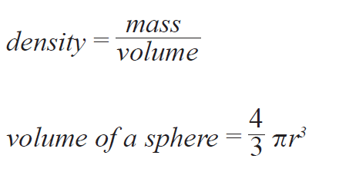

The Kepler mission is particularly concerned with finding planets that lie within the habitable zones of stars. A planet in a star’s habitable zone receives the right amount of energy from the star to maintain liquid water on its surface, provided it also has an appropriate atmosphere.

(e) By comparing the Kepler 20 system and our own solar system, suggest which

planet in the Kepler 20 system is most likely to lie in the habitable zone. Explain your answer. (3 marks)

_____________________________________________________________________

_____________________________________________________________________

_____________________________________________________________________

_____________________________________________________________________

_____________________________________________________________________

_____________________________________________________________________

_____________________________________________________________________

**Question 14 (15 marks)**

An astronaut on a **distant planet** performs a “loop-the-loop” experiment. She releases a 1.3 kg cart from a height of 4.50 m. Assume any friction between cart and track is negligible. The gravitational field strength of the distant planet is **gplanet**. The speed of the cart at the top of the circular loop is **vtop**. It is observed that the track exerts a normal reaction force of 21 N on the cart at the top of the loop.

a) Draw and label clearly the forces acting on the cart at the top of loop.

(2 marks)

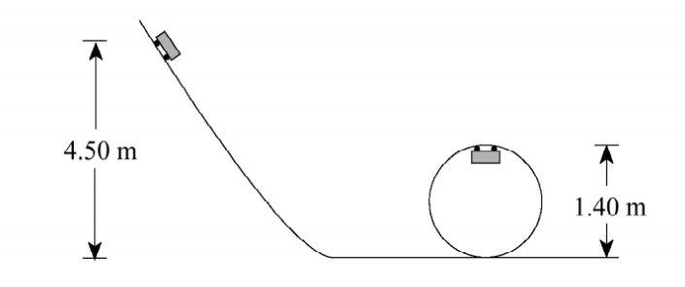

b) The astronaut derived the equation (vtop)2 = 5.3 gplanet

Using physics principles and calculations, justify clearly if you agree with the astronaut.

(5 marks)

_____________________________________________________________________

Space for calculations:

1. Calculate the gravitational field strength on the distant planet using your physics understanding of vertical circular motion. (4 marks)
2. The astronaut has returned to Earth and is designing a racetrack. The racetrack surface has the shape of an inverted cone on which cars race in horizontal circle shown below.

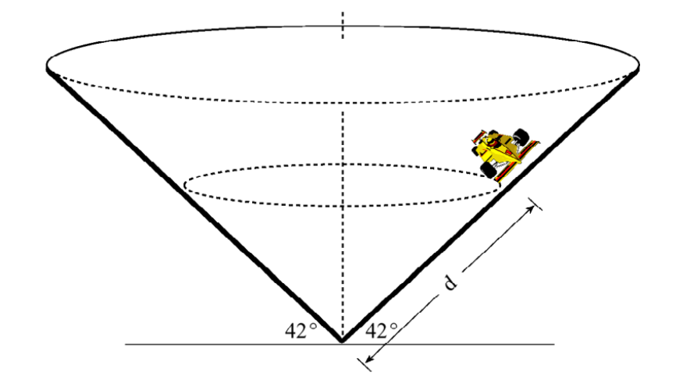

For a steady speed of 29 m s-1, calculate the distance **d,** a driver should drive her car if she wishes to stay on a circular path without friction? (4 marks)

**Question 15 (15 marks)**

A person bending forward to lift a load with his “back” rather than with his “knees” can be injured by the large forces acted on the back muscles and vertebrae.

To consider the magnitude of the forces involved in such poor lifting practices, consider the simplified diagram for a person lifting a 25.0 kg load (L) below.

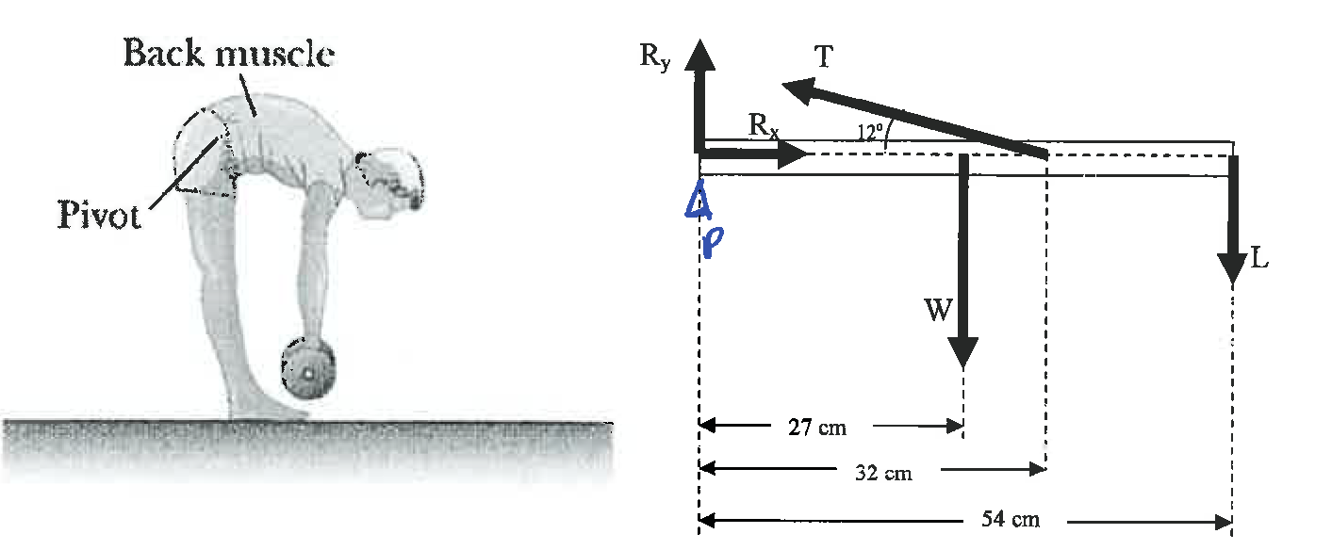

The spine and upper body are represented as a uniform horizontal rod of 41.5 kg (W) pivoted at the base of the spine (P). The erector spinalis muscle acts at an angle to horizontal of 120 to maintain the position of the back. The components of the reaction force (Rx) and (RY) are also shown on diagram.

a) Determine the tension (T) in the erector spinalis muscle while in this position.

(4 marks)

b) Determine the **horizontal component of the reaction force on the spine**

**(Rx)** while in this position. (2 marks)

c) Determine the **vertical component of the reaction force on the spine (RY)**

while in this position. (3 marks)

d) Determine **the reaction force on the spine (R) (which is not shown on the**

**diagram)** while in this position. (3 marks)

1. Describe and justify three strategies using physics principles for a person to lift heavy objects. (3 marks)

_____________________________________________________________________

_____________________________________________________________________

_____________________________________________________________________

_____________________________________________________________________

_____________________________________________________________________

_____________________________________________________________________

_____________________________________________________________________

_____________________________________________________________________

_____________________________________________________________________

**Question 16 (15 marks)**

The schematic diagram below shows an electric motor that produces a magnetic field from field coils on either side of the armature coil. It is called a series-wound motor because the field coils X and Y are wired in series with the armature coil.

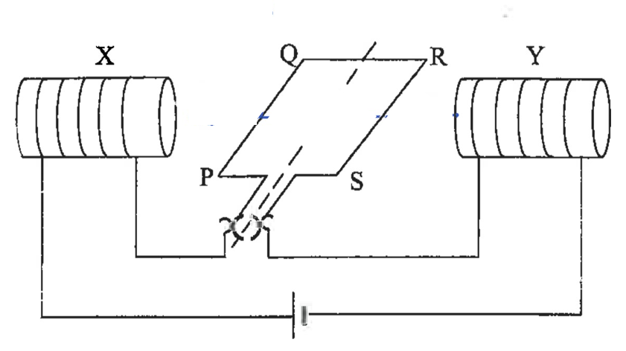

* The armature coil of the motor has 150 turns.
* Side PQ is 5.0 cm long and side QR is 4.0 cm long.
* A 12 V supply provides a current of 0.75 A and generates a 0.095 T magnetic field across the armature coil.

1. i) Draw and label (B) the direction of the magnetic field. (1 mark)

ii) Draw and label (F) the direction of the force of side PQ. (1 mark)

b) Calculate the force on the side RS of the armature. (3 marks)

c) Sketch the graph below of the force on the side PQ (vertical axis) versus time t (horizontal axis) for this simple motor.

For the time axis, show time from time t = 0 to 1.75 T where T is the motor’s period. (2 marks)

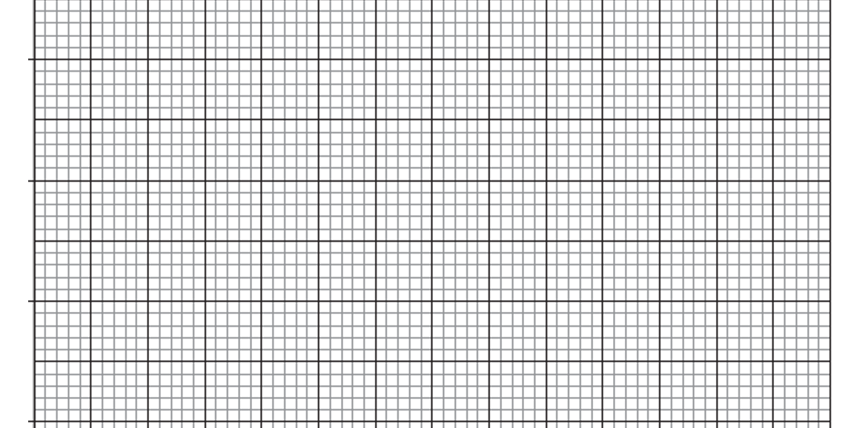

d) Determine the torque produced when the plane of the armature coil is at an

angle of 300 to the magnetic field. (3 marks)

e) Describe and explain two practical ways in which the motor can be modified to produce a greater torque. (2 marks)

_____________________________________________________________________

_____________________________________________________________________

_____________________________________________________________________

_____________________________________________________________________

1. One advantage of this type of motor is that it works on either AC or DC electrical supplies. Using either or both diagrams below as part of your answer, explain why and how this motor will turn with respect of the type of electrical supply provided. (3 marks) 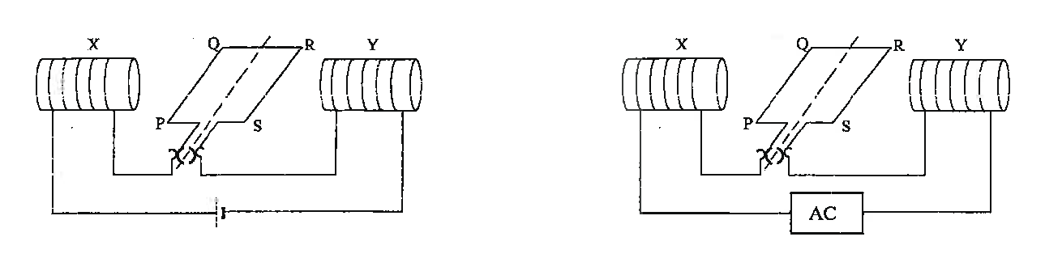

_____________________________________________________________________

_____________________________________________________________________

_____________________________________________________________________

_____________________________________________________________________

_____________________________________________________________________

_____________________________________________________________________

_____________________________________________________________________

_____________________________________________________________________

_____________________________________________________________________

_____________________________________________________________________

_____________________________________________________________________

**Question 17 (15 marks)**

The Earth’s moon has always been of primary interest to astronomers and this lead to one of the most significant achievements of the 20th century – Man landing on the Moon.

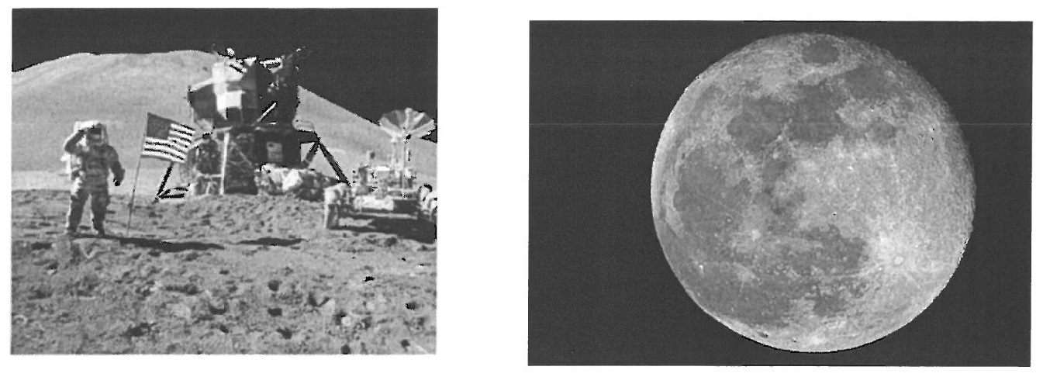

a) Calculate the period for the Moon in orbit around the Earth. (5 marks)

1. An important aspect of the Apollo Lunar landing missions was the return of the Lunar Landing Module (LM) to the orbiting Command Service Module (CSM) before returning to the astronauts to Earth.

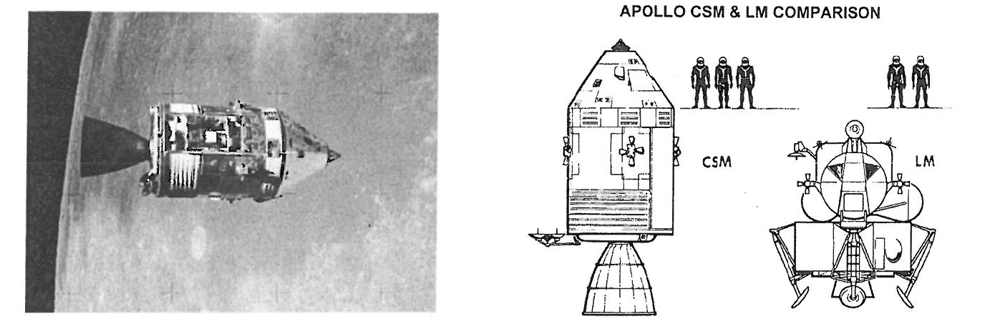

**Determine the height above the Moon’s surface** for which an orbit will effectively allow a Command Service Module to remain “fixed” above the Landing Module situated on the Moon’s surface. (6 marks)

Assume the period of rotation of the Moon is 27.3 days.

1. On the diagrams below, carefully illustrate and indicate direction of a polar orbit and a geostationary orbit. (4 marks)

 

Polar Orbit Geostationary Orbit

END OF SECTION TWO

**­­­­­­­­­**

**Section Three. Comprehension. 20% (36 Marks)**

This section has **two (2)** questions. You must answer **both** questions. Write your answers in the spaces provided.

When calculating numerical answers, show your working or reasoning clearly. Give final answers to **three** significant figures and include appropriate units where applicable.

When estimating numerical answers, show your working or reasoning clearly. Give final answers to a maximum of **two** significant figures and include appropriate units where applicable.

Additional working space pages at the end of this Question/Answer booklet are for planning or continuing an answer. If you use these pages, indicate at the original answer, the page number it is planned/continued on and write the question number being planned/continued on the additional working space page.

Suggested working time: 40 minutes.

**­­­­­­­­­**

**Question 18:** **(18 marks)**

**The Mass of an Electron**

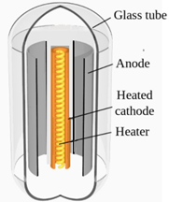A tuning eye tube, also known as a magic eye tube, is a vacuum tube where electrons are released from a hot cathode at the centre. The electrons are then accelerated towards two anodes. The anodes form a semi-circular funnel shape around the cathode. These electrons are accelerated towards the anode by an accelerating voltage (Va). Refer to Figure 1 for more details on the structure of this tube.

**Figure 1:** Tuning eye tube

When the accelerated electrons hit the anode fluorescence occurs, releasing a pale green light. The pattern that the fluorescent light forms is that of two fan-shaped beams of light with straight edges, as shown in Figure 2a and 2b below.

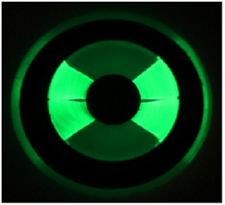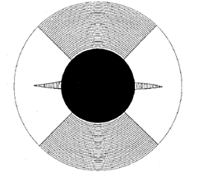

**Figure 2a**: Top view of the fluorescent **Figure 2b:** Actual image of the

pattern when the tuning eye tube is not fluorescent pattern without

exposed to a magnetic field. exposure to a magnetic field.

The tuning eye tube is then placed inside a solenoid as shown in Figure 3 below.

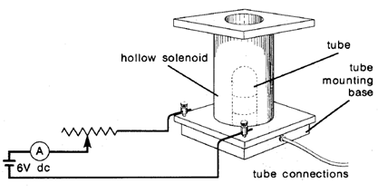

**Figure 3:** Tuning eye tube placed inside a solenoid that is connected to a variable resistor which allows current to the solenoid to be adjusted.

When a particular current is passed through the wire coils of a solenoid, a uniform magnetic field is generated inside the solenoid. Thus the electrons in the tube experience a uniform magnetic field, shown in Figure 4.

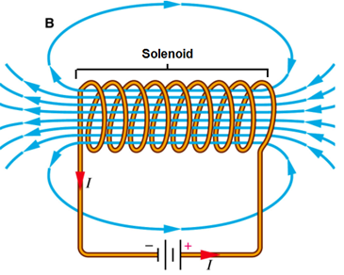

**Figure 4:** Uniform magnetic field inside a current conducting solenoid

The magnetic force is supplying all the centripetal force, since the tuning eye tube is a vacuum tube. When the tube is exposed to a uniform magnetic field the electrons are deflected by this magnetic force into a circular arch that has a measurable radius of curvature, R as shown in Figure 5a and 5b. The radius of curvature, the strength of the magnetic field inside the solenoid, and accelerating voltage are all used to determine the mass of the electron.

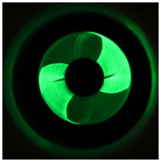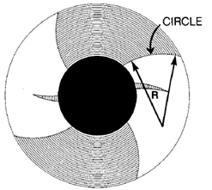

**Figure 5a:** The electrons are deflected by the **Figure 5b:** Actual image of tube

magnetic field to create an arch that has a exposed to a magnetic field.

measurable radius of curvature, R.

a) The equation for the mass of an electron is:

m = R2qB2 2Va

1. Starting with the equation for the work done on the electron then using force equations derive the above equation for the mass of an electron. (3 marks)
2. If the edge of the fanned out beam is arched to have a radius of curvature of 1.16 cm in a magnetic field of 4.5 mT and the tube has a voltage of 240 V then what is the mass of an electron according to this study? (2 marks)

b) i. Using 9.11 x 10-31 kg as the mass of an electron and given that the voltage difference across the anode and cathode is 240V and assuming the electrons released from the cathode have no initial velocity, determine the acceleration of the electrons towards the anode. (2 marks)

ii. If protons were used instead of electrons state by how many times the voltage would need to increase to get the protons to achieve the same acceleration as the electrons. Show your calculations. (2 marks)

c) Given that the mass of an electron is 9.11 x 10-31 kg and that the initial velocity of the electron leaving the cathode is zero. Use the average velocity of the electron as it travels towards the anode, perpendicular to the magnetic field, to estimate the magnitude of the deflection due to a magnetic field strength of 250 µT. The distance between the anode and cathode is 1.00 cm. Note: The accelerating voltage supplied to the tube is still 240V. If you were unable to solve for the acceleration in part (b) i. then use a value of 4.40 x 1013 ms-2. (8 marks)

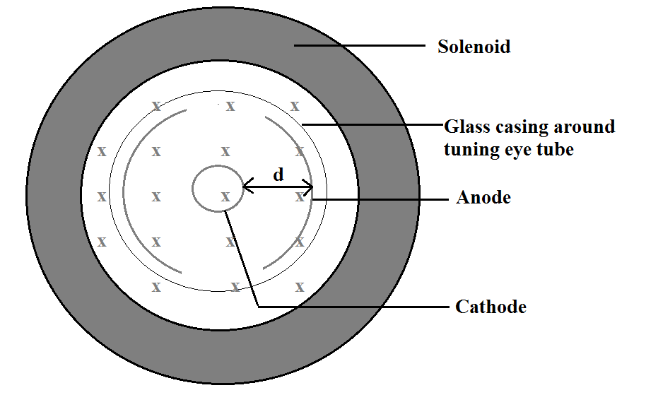

**Figure 6:** Tuning eye tube inside a solenoid that is producing a magnetic field

d) Using the information show in figure 6 in part (c) determine if the electrons are deflected in a clockwise or anticlockwise direction. ( 1 mark )

___________________________________________________________

**Question 19:** **( 18 marks )**

**Coulomb’s Law**

The electrical force that electrically charged particles can exert on each other is much stronger than the gravitational force. The strength of the electrical force can be expected to depend on the magnitude of the charges and on the distance between them. The formula governing the exact nature of the relationship or very small charged particles has become known as Coulomb’s Law (after Charles-Augustin Coulomb, 1736-1806).

The methods used to study Coulomb’s Law all involve balancing the electrical force with other forces that are easier to measure.

In the PSSC-type Coulomb’s Law Apparatus shown in Figure 7 a pith ball (a Styrofoam low mass ball) is suspended on a light weight string in such a way that its movement is confined to one plane. A grid is placed under the pith balls, with a ruler placed behind the grid allowing easy measurement of distances.

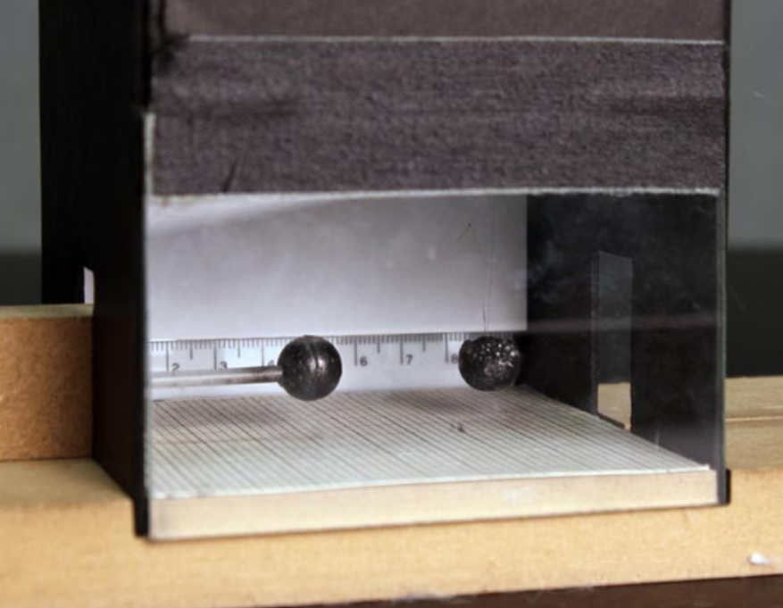

**Figure 7**: PSSC-type Coulomb’s Law Apparatus

The pith ball is then electrically charged by transferring electrons onto it using a charged acetate strip. An identical pith ball is given an exactly equal charge using the same acetate strip. This second pith ball is then placed a distance, R from the first pith ball. This causes the suspended pith ball to deflect a linear distance, d, as shown in Figure 8 on the next page.

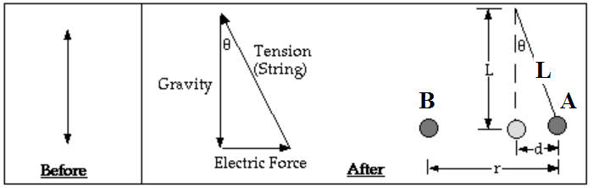

**Figure 8:** Deflection of the suspended pith ball, labelled A by an equally charged pith ball labelled B.

From Figure 7 d/L = sinΘ and the force in the x direction pushing on the pith ball is

F = mgsinΘ.

1. Use the above information to derive a formula that shows that the electrostatic force is directly related to the distance d that the pith ball is deflected. (1 mark)
2. Next use your equation from (a) to show that the square of the distance between two pith balls R2 is inversely proportional to distance the pith ball is deflected, d. Isolate for R2 and rearrange the equation to determine the gradient of the line if you plotted R2 on the y-axis and 1/d (or d-1) on the x-axis. (3 marks)
3. Fill in the missing values in the table below. (2 marks)

|  |  |  |  |  |  |  |
| --- | --- | --- | --- | --- | --- | --- |
| Ruler position of the suspended pith ball prior to being charged (cm) | Ruler position of stationary charged pith ball  (cm) | Ruler position of the suspended,  deflected pith ball (cm) | R  (m) | R2  (m2) x 10-3 | d  (m) | 1/d  (m-1) |
| 7.00 | 1.50 | 7.90 | 0.064 |  | 0.009 |  |
| 7.00 | 2.00 | 8.01 | 0.060 |  | 0.010 |  |
| 7.00 | 2.80 | 8.30 | 0.055 |  |  |  |
| 7.00 | 3.20 | 8.40 | 0.052 |  | 0.014 |  |
| 7.00 | 3.80 | 8.60 |  |  | 0.016 |  |
| 7.00 | 5.35 | 9.36 | 0.040 |  | 0.024 |  |
| 7.00 | 6.06 | 9.76 | 0.037 |  | 0.028 |  |

1. Graph R2 on the y-axis and 1/d on the x-axis on the graph paper on the next page. Additional graph paper is supplied at the end of this question if required.

(4 marks)

1. Draw the line of best fit and determine the charge on the pith balls given that the pith ball has a mass of 2.00g and the length of the string is 50 cm. (3 marks)

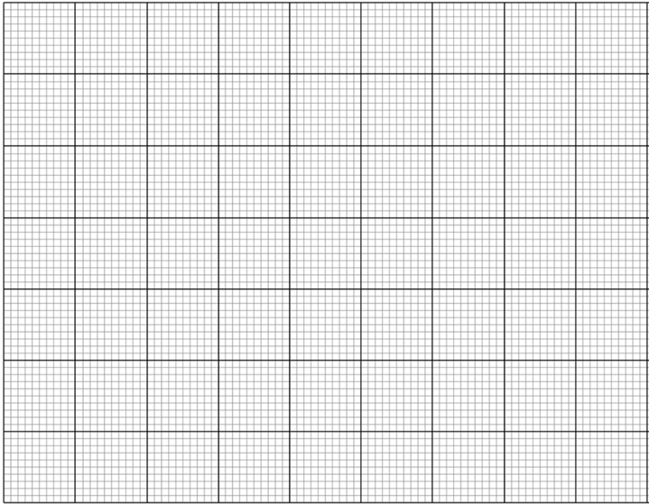

In another version of the PSSC type apparatus the pith ball is suspended by two strings. Refer to Figure 9 below.

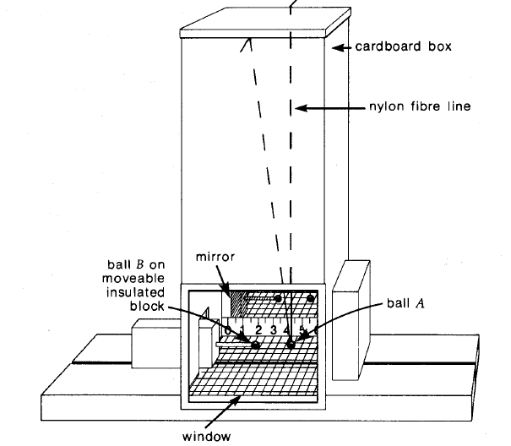

**Figure 9:** PSSC-type Coulomb’s Law Apparatus

1. 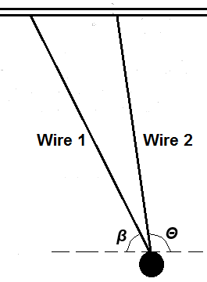When a 8.00 mN electrostatic force acts horizontally on a pith ball the following equilibrium occurs, with the following angles being created, *β* = 60o and *Θ* = 110 o.
2. If the tension in wire 1 is 9.513 mN what is the tension in wire 2? (2 marks)
3. What is the mass of the pith ball in grams? (3 marks)



Additional working space

|  |  |  |  |  |
| --- | --- | --- | --- | --- |
| Question number: |  |  |  |  |

Additional working space

|  |  |  |  |  |
| --- | --- | --- | --- | --- |
| Question number: |  |  |  |  |